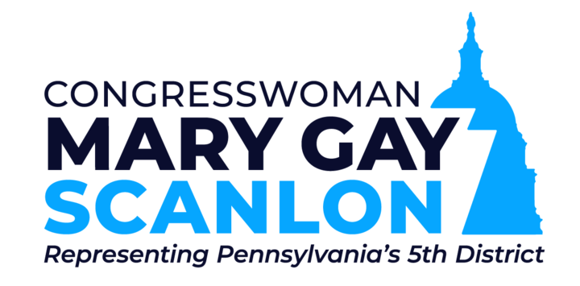

Applications for Community Project Funding for Fiscal Year 2023
Deadline for submission: Friday, April 22, 2022

Dear Friends,

The U.S. House of Representatives is allowing members of Congress to recommend specific projects in our communities for direct funding through federal appropriations. Each member of Congress is permitted to request up to fifteen Community Project Funding (“CPF”) requests. This packet will provide some information about how to submit your request for consideration.

The amount of funding for directed projects is limited and all proposals will be subject to considerable scrutiny and competition with other projects around the nation. If you choose to submit a project for consideration, you should expect your organization to be audited by the U.S. General Services Administration.

Once our office submits our fifteen requests for CPF funding, the House Committee on Appropriations will examine the requests made by all members of Congress and will select a small percentage to be included in the appropriations bills. Then, the U.S. Senate Committee on Appropriations will separately consider CPF funding requests submitted by U.S. Senators. If both chambers select a project for inclusion in the federal budget, and the budget passes and is signed by President Biden, a federal agency then will be tasked with doing a final review, audit, and then dispersing the funds. Because this process will be lengthy, you should not submit any request for an urgent need. You should expect that even if your project is selected for funding, it may take over 18 months for the check to be cut.

The House Committee on Appropriations requires certain information to be submitted with each project request, including documentation of evidence of “strong community support.” My office has also chosen to prioritize grants that will increase economic, racial, gender, environmental, disability, education, or age equity in PA-05.

Here are the key criteria for CPF grant requests:

- No member of Congress, including myself, or immediate family of members, can have a financial interest in the grant request;
- For-profit institutions are ineligible for CPF grants;
- Our office’s cap on funding for individual projects is $2 million per project;
- Grant requests must demonstrate substantial community support and need;
- Applicants should understand that project funding is not immediately available as it will be distributed through the following year’s federal budget;
- Projects are funded for only one year and are not renewable. Requests made in the 2022 cycle are for the Fiscal Year 2023.

In the 2021 application cycle, the Appropriations Committee showed a specific preference for projects that would be “fully funded” through the CPF, or where the CPF was “last dollar” needed to complete the project. By way of example, if you are asking for $2 million of a $10 million project, and you do not have the other $8 million already in your organization’s bank account, the Committee is significantly less likely to fund your project (and, accordingly, we will be less likely to submit it to the committee for consideration).

Finally, each congressional office will have its own internal evaluation process and will likely require you to complete application materials that are separate and distinct from this document. Should you decide to submit an application to any other member of Congress, or to one of Pennsylvania’s U.S. Senators, you should contact that office for details on its requirements and deadlines.

Finally, to ensure a fair playing field for all applicants, we will not be holding staff- or member-level meetings on any CPF project request until the end of this process. We are happy to answer technical or procedural questions about the CPF application. Such questions should be submitted to pa05.CPF.2022@mail.house.gov. If we have follow up questions about your project, we will reach out.

As always, please feel free to contact my office if you have any questions.

Sincerely,
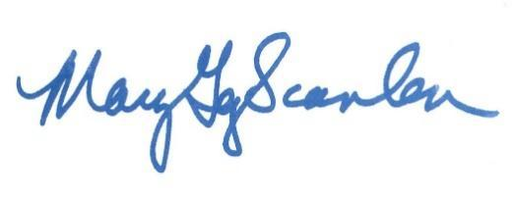

Mary Gay Scanlon
Member of Congress

Instructions for Submitting PA05 CPF Requests

Submission/Deadline: Please complete this Google form, https://forms.gle/LPj7UGP4V8jnVQCA9. After you have submitted the Google Form, send the specifically requested supporting documents to pa05.CPF.2022@mail.house.gov. Every email should use this format for the subject lines: [ORGANIZATION NAME] – [PROJECT TITLE]. All attachments must be in PDF format. Both the Google form and supporting documents must be submitted by close of business Friday, April 22, 2021. You will receive a confirmation response to your email when you submit.

Multiple Projects: If your organization intends to submit CPF Requests for multiple projects, please email pa05.CPF.2022@mail.house.gov with a letter prioritizing your requests. The subject line of this email should be: [ORGANIZATION NAME] – PRIORITIES.

Supporting Documentation: After submitting the Google Form, submit the below documents to pa05.CPF.2022@mail.house.gov as PDF attachments.

- Evidence of “Significant Community Support”: We ask that you submit written statements evincing your project’s “significant community support”. Examples include letters from local officials, notices of other grant awards such as RACP grants, news coverage on the issue your project is attempting to address, and community testimonials.

- Equity Statement: Please submit a statement, no more than 500 words, describing how your project will increase economic, racial, gender, environmental, disability, education, and/or age equity in PA-05

- Certification of Non-Profit Status (if applicable)

- Agency-Specific Documentation (if applicable): If you are applying for funding from the Army Corps of Engineers or the Department of Defense, or if your project is a Transportation Project, please submit the relevant supplemental sheet below (Attachments 1-3).

- Signature Page: See Attachment 4.

Note: Please submit all relevant statements and supporting documentation in a SINGLE email to pa05.CPF.2022@mail.house.gov.

Matching Fund Requirement: Several Federal programs eligible for CPF requests require a State or local match for projects either by statute or according to longstanding policy. It is the applicant’s responsibility to determine if their CPF request has a matching fund requirement.

Questions: If you have any questions, please email pa05.CPF.2022@mail.house.gov. While the office will not be taking meetings on the merits of specific projects, we will answer technical questions as to the application or process.
ATTACHMENT 1

Army Corps of Engineers Project Supplemental

This section is ONLY applicable to Army Corps projects.

Please specify if funding is requested for a (please check one if applicable):

____ New Study
____ Ongoing General Investigation (Reconnaissance study phase; feasibility study phase; preliminary engineering and design phase)
____Construction
____Operation and Maintenance

If applicable, please provide the Authorization (P.L. # and Section).
Example: WRDA 1986, P.L. 99-662, Section 501(a).

ATTACHMENT 2

Defense Appropriations Supplemental

This section is ONLY applicable to Defense projects.

What service will your project serve (please check only one):

___ Army  ___ Army Reserve  ___ Navy  ___ Navy Reserve | ___ Marine Corps  ___ Marine Corps Reserve  ___ Air Force  ___ Air Force Reserve | ___ Army National Guard  ___ Air National Guard  ___ Defense-Wide  ___ Intelligence

Appropriations Account (please check only one)

___ RDT&E  ___ Procurement  ___ Personnel | ___ O&M  ___ Counter Drugs  ___ Medical | ___ Reserve Equipment  ___ Nat’l Guard Equipment  ___ Other

Line Item Title:

R-1/PE #:
P-1/Line #:
Other:

Sub-Activity Group (required for Personnel, and O&M):

Bill and/or Report Language (only required if part of overall request and designate whether bill or report language – Please keep length to an absolute minimum.):

Has the Department or any of the individual services expressed a need for the item or capability that your organization expects to provide in the event that this project receiving congressional funding?

Assuming (a) that the Department or any of the individual services has expressed a need for this item and (b) that you are requesting funding beyond that provided in the President’s budget, please explain why the Department has not provided sufficient funding for this initiative in its proposed budget?

How will this item or capability benefit troops and other military personnel currently in the field?

ATTACHMENT 3

Transportation Appropriations Supplemental

This section is ONLY applicable to transportation-related projects.

Please list the municipalities that will be impacted by this project.

Has the Commonwealth, county, or city governments performed any studies or published any reports on the necessity or impact of this project? If so, please describe in two paragraphs below and attached the studies or reports as PDFs.

Which agency within the U.S. Department of Transportation has authority to allocate funding for this initiative (examples: FAA, FHWA, FRA, FTA, etc.):

If you have identified one or more programs or accounts administered by that agency best suited to your project, please list those programs or accounts here (examples: STP, Bus and Bus Facilities, etc.)

Have you confirmed with U.S. DOT or a regional U.S. DOT office that this project is eligible for funds provided under the requested account?

Have you confirmed with PENNDOT or a regional PENNDOT office that this project meets their eligibility guidelines?

Is this project included on Pennsylvania’s State Transportation Improvement Program list?

In two paragraphs or less, please provide information on how this project will reduce congestion or otherwise improve our local transportation system.

In two paragraphs or less, please provide information on how this project will promote economic development or otherwise encourage economic growth.

ATTACHMENT 4 - REQUIRED OF ALL APPLICANTS

PA05 CPF Request: Signature Page

Do you attest that everything contained in this document is accurate and submitted without any motivation of fraud or self-dealing?

_____ YES _____ NO

Do you acknowledge that by submitting your request you understand the amount requested; proposed recipient’s name and address; description of the project; and all other information contained herein will be made available to the public if the Congresswoman submits your request to the Committee on Appropriations?

_____ YES _____ NO

Do you acknowledge that by submitting your request you consent to a full audit by the U.S. General Services Administration or any other relevant government agency?

_____ YES _____ NO

______________________________
Signature of Person Legally Authorized to Bind Organization

______________________________
Printed Name

______________________________
Date

